Helena Oikarinen-Jabai
University of Helsinki, Finland

In my presentation I will discuss my two research projects that deal with belonging and identifications of second generation immigrant youth in Finland. The first project A Finn, a Foreigner or a Transnational Hip-hopper? Participatory Art-Based Research on the Identification Negotiations and Belongings of the Second Generation Finnish Immigrant Youth I conducted with different teams of participants, artists, art educators, museum staff and cultural and media workers in 2009-2016. The other project Young Muslims and Resilience: A Participatory Study will be conducted with a group of young participants, three researchers and other actors in 2016-2018. This study is on progress.
Both research projects are using performative creative and visual methods and are based on idea of participants being go-researchers, and their voices and perspectives are an important part of research reporting and research findings (Denzin 2003; O’Neill 2008, Liebenberg 2009). The previous research was conducted at Aalto University, School of Art, Design and Architecture, Art Department. The present research at University of Helsinki in Department of Social Studies.
I will show examples of my study, and discuss how cultural citizenship, diasporic imagination and religious identifications are expressed in the presentations and productions of participants. (Brah 1996; Hua 2011). I will also ask how possibly connect the concept of resilience (common in social sciences) may be applied to participatory performative research approach.
Background
In my previous study I have leaned on postmodern, postcolonial and post-structural feminist theories and reporting methods (e.g. Anzaldua 1987; Behar 1995; Haraway 2004; Jagne 1994; Minh-ha 1991) and researchers speaking on behalf of performative writing (e.g. Denzin 2003; Richardson 1997; St. Pierre 2005), also creating texts based on various genres.
To create texts that would challenge the ideas of hegemonic power relations and create hybrid encounters, I have drawn on life writing (Kadar 1992), ethnographic fiction (Behar 1993; Viswesvaran 1994) and other experimental performative approaches (Anzaldua & Moraga 1983; Cixous 1993; hooks 1995; Fusco 1998; Kristeva 1992; Lather & Smithies 1997; Richardson 2005; Denzin 2003; Min-ha 1991).
In the research project that dealt with identification and sense of belonging of the second generation youth performative approaches helped me expose the embodied and sensual knowledge hidden within my data and encounter participants as actors and speakers whose voice and perspectives matter (Richardson 1997, 59). Also, working with performative narratives enabled to crack open such binary notions as science and art, fiction and non-fiction, universal and personal, objectivity and subjectivity, outsider and insider, and to express different cultural aesthetics, styles and approaches (Minh-ha 1991, 65; Oikarinen-Jabai 2015a).
The project concerning young Muslims and resilience was for me it was a continuation of my former study - within which their religion was an important topic to deal with for Muslim participants. The project is still in progress. In 2016 we started to collect data and plan an exhibition with the participants (I am especially responsible for the female participants) that will staged in November 2017. In this study we also leant on participatory research methodology developed by Professor Michael Ungar and his colleagues by Resilience Research Center in Halifax, Canada (http://174494.resilienceresearch.org/).
Material
My research resulted in a variety of projects and exhibitions with different teams of artists, young people, cultural and museum workers and educators. With young Finnish Somalis. I began working with them in 2009, when I opened photography and video workshops with Sami Sallinen in the Youth Multicultural Living Room, founded by the Youth Department of the City of Helsinki. During 2010 we met regularly with the five men who participated in these workshops; although other young people were sometimes also present as ‘visitors’. A number of other activities were also organised in the Multicultural living room.
Often our role as leaders was that of facilitators. The participants could borrow cameras in order to video and photograph their everyday lives when it best suited them, but we met regularly to talk, edit and spend time together. As part of the process, the participants interviewed each other, and sometimes we went out together to take photographs.
The first larger photo/video exhibition connected to the project was at the Music Library, located in the centre of Helsinki, in December 2010 and January 2011. The exhibition included photos by 10 young Finnish Somali men and a documentary video. Since then the exhibition has been shown in several places, sometimes as part of different exhibitions. The participants and I have also presented their work at different seminars and festivals, where we have also shown the material produced in the project.
In 2011 we made the radio programme Where is my space? with five young Somali men and one young Somali woman. It was broadcast on YLE, Finland’s national public service broadcasting company. In 2012 the book Mun Stadi (My Town) was published, based on the stories and photos of seven young Somalis. In 2013 we made the final version of the video documentary Minun Helsinkini/My Helsinki/Wa Magaaleydi Helsinki.
In 2013 an exhibition by a young Somali woman, photographs and an installation, along with the works of some young Somali men, were presented at the Institute of Migration, Turku, Finland. We worked with the Somali woman over a long period to create the book Toisin silmin/By Different Eyes (2015). She took photographs in Finland, in England, where she used to study, and in Somalia, which she had visited for the first time since she had left it as a small child.
In 2014 the young male participants wished to make a follow-up to the first video, and hence the video documentary Soo Dhawoow/Tule lähemmäs/Come closer was created in 2015 with a team of young Somali men, Art Educator Joel Gräfnings and myself. It was broadcast by YLE, Finland’s national public service broadcasting company, in 2016.
In the present project the participants have produced some data for example photographs, videos, paintings and poems, and we are in the process of producing art works productions based on that material. In their material they deal with issues such racialisation, ethnicity, religion, multilinguality, sexuality, gender positions, clothing and aesthetics, food, and local/glocal/global sense belonging.

Methodology
The material created during the research process constitutes a major part of my research data. One of the central ideas of the research is that when creating audio-visual material and productions together with other team members, young people act as co-researchers, participating in the reporting of the research by describing their sense of belonging and narrating stories about their embodied spaces (Finley 2005; O’Neill 2011).
To develop a dialogical field setting, I have drawn on Nira Yuval-Davis’s (1997) concept of unfinished knowledge. It is based on transversal politics, which allow homogeneity to be superseded with dialogue, thereby enabling the different voices and positions of the participants to be heard. Research participants do not act as representatives of identity categories but rather as examples of how to engage reflectively in ‘rooting’ and ‘shifting’ (Yuval-Davis 2011, 12). This approach allows belonging and identifications to be understood as negotiable – a mesh of intersecting forces and desires that may pull in multiple directions.
In a performative research setting, research findings can be presented, for example, in the form of poetry, (moving) pictures, music and sound and in various digital formats (Denzin 2003; Haseman 2006; Richardson 1997). This creates polyvocality, hybridity and the capacity to bridge differently valued knowledges and subjugated moods in the research field (Conquergood 2009, 318). Above and beyond this, performative approach allow people to deal with their embodied experiences and enable them to move toward the other side of speech and representations, where the opened boundary may allow the creation of multiple voices and bring fresh, emerging views into focus (Ashcroft 2001; Minh-ha 2011, 94; Tolia-Kelly 2007).
Dwight Conquergood (2009, 312) claims that if we want to understand the experiences of subjugated people, we should lean on a ‘knowing how’ and a ‘knowing who’, grounded in active, intimate, hands-on participation and personal connection and rooted in embodied experience, orality and local contingencies. By embracing both written scholarship and creative work as research approaches, the hegemony of the text is challenged, and texts and performances are reconfigured in horizontal, metonymic tension. Laurel Richardson (1997) argues that turning data into poetry can make visible the underlying labour of sociological production and its conventional rhetoric. Narrative and poetic representation can touch our bodies in ways that are different from the effects of standard scientific transcriptions. This makes it possible to reflect the research story on a sensory and cognitive level.
Maggie O’Neill defines her approach, which involves working in collaboration with artists, performance artists, writers, poets, photographers and participants in the space between ethnography and art, as ‘ethno-mimesis.’ ‘Ethno-mimesis’ involves a methodological practice, a process that enables the inter-textuality of biography/narrative (ethnography) and art (mimesis) to become a ‘potential space’ for transformative possibilities (O’Neill 2008, 3).
O’Neill (2009) claims that participatory performative approaches are especially useful when dealing with transnational and diasporic experiences because they encompass praxis as purposeful knowledge, which tells us, in a relational and phenomenological sense, something about what it is to feel ‘at home’ and have ‘a sense of belonging’. Furthermore, biographical and art-based research may involve inquiry that reveals the embeddedness of small-scale phenomena in the broader social totality and allows belonging to be understood as socially constructed, negotiated and contested in interpersonal, intrapersonal and cultural frameworks (Brah 2001; Oikarinen-Jabai 2015b; O’Neill 2011; Pink 2007; Liebenberg 2009).
Avtar Brah (1996) argues that social relations, experience, subjectivity and identity are ‘differential’ categories situated in multiaxial fields of power relations. The similarities and differences across axes of differentiations – with regard to class, race, gender and equality, for example – are articulated (or disarticulated) in the diasporic space within a complex web of power. Bill Ashcroft (2001) maintains that the notion of horizon challenges the concept of boundary and may facilitate the emergence of different dimensions of hybrid postcolonial subjectivity.
In both discussed projects it is obvious that – in addition to their other purposes – the audio-visual and literal narrations created with participants are means to create hybrid stories that challenge hegemonic notions of belonging and enable it to be understood as an embodied, multi-layered and fragmentary horizontal process (Ashcroft 2001; Conquergood 2009; Minh-ha 1991, 6; Oikarinen-Jabai 2015a).

Glocal belonging and homes in many places

In the both projects it has been obvious that both in the research process and in their productions, the participants approach belonging from multiple perspectives, creating – together with the research team – stories that explore and expose a transversal landscape that is at same time personal and can be understood also as a generational story. (O’Neill 2008; Oikarinen-Jabai 2015b).
In all the material produced in the project, the participants speak warmly about their relationship to the places where they have lived in Finland. Local identifications and bonds are strong. As one young man stated in the book My town, ‘Helsinki is my beloved home; I have been to all the backyards and peeped under every stone.’ In the book My town one young man states.
Even though I don’t see myself as a Finn, this is my home country or something in-between. I have a lot of friends here. I was born here, I went to school and I grew up here. I get along in Finland. After school I would like to see the world a bit, but I think I’ll stay here. I’m used to living here. My friends are also from all parts of the world, but I often talk in Finnish to them. I guess we are some kind of a new generation of Finns, and each one is also slightly something else. (My town 2012, 5)

In the video documentary Minun Helsinkini/My Helsinki/Wa Magaaleydi Helsinki, one young man remembers his childhood by drawing on videos and photos, also from his childhood. The audience can sense and feel his deep attachment to his home and the garden around it, kindergarten, school and the parks where he used to hang around and play football. When the camera moves around the day care centre playground, he recalls:
This was the first day care centre I went to. I remember the first time I came here. I wouldn’t let to go of my mother. I tried to escape because it was the first time I had to leave my mother. I remember telling my mother every single day to wait at exactly this spot. My mother always reminds me that I used to pull her hand and say, ‘Don’t leave me!’ (Minun Helsinkini/My Helsinki/Wa Magaaleydi Helsinki)
In addition to important childhood places, the family has an important place in most participants’ stories. Also, the diasporic community and the transnational and transversal spaces to which they concretely belonged through kinship relations offered them the possibility to understand home as an imaginary place with routes and roots in the past, present and future (e.g. Ahmed 2000, 78; Ashcroft 2001; Brah 2001; Minh-ha 2011, 27). In the book and installation by the female participant, visual images and depictions of family play an important role. In the book By Other Eyes she says:
My home country is always Somalia but home is where one’s family and memories are, which is Finland. Home and home country are different things in my opinion, and I see myself first as a Somali and then – not necessarily quite as a Finn – but as a person from the country of Finland. Above all, I see myself as an international Somali. (By Other Eyes 2015, 5).
Sense of citizenship
Even though the participants shared a kind of ‘horizontal’ or ‘nomadic’ cultural citizenship, for most of them their relationship with Finland and Finnishness was rather complicated (e.g. Oikarinen-Jabai 2005a; Ashcroft 2001, 187; Joseph 1999, 155). Finland was everyone’s home country, at least one of their home countries, but these young people often discussed, sometimes heatedly, the question of being a Finn, how to be a Finn and whether there was a need to be a Finn if one lived in Finland.
In the documentary Soo Dhawoow/Tule lähemmäs/Come closer, when the young people discussed their belonging and identifications in different sequences, one participant consistently proclaimed his right to be a Finn and belong to Finland. When the participants discussed their Finnishness he remarked:
Finnishness does not mean that . . . generally immigrants think . . . that if you are born in Finland you are like a Finn, if you are like that, that you are one of them, Pekka and Jari or Timo and so on. You go with them to have a beer, and then later in the evening to the sauna. To be a Finn does not mean that. Finnishness means that . . . it depends on the person, where he comes from and where his roots are. . . . If you are a Finn, it does not mean that you have to participate totally in Finnish culture. You have your own roots, your own culture, but at same time you can be a Finn. (Soo Dhawoow/Tule lähemmäs/Come closer)

Nevertheless, another participant challenged him on this: ‘If the majority decides that you are not a Finn, five million people think that you are not a Finn, are you then a Finn? His answer was that ‘the majority does not decide anything, if there were five million or ten million, I don’t let others, I stand alone then. There followed a heated discussion where two of the participants defended their right and the right of anyone living in Finland to call themselves Finns, and two of them defended the idea that if the majority thought you were not part of the Finnish nation, you could not claim that you belonged. They continued by raising arguments and counter arguments, a common communication and discussion habit among the participants, until the pro-Finn stated: ‘I think that you two, that you two have more traumas than we do. . . . I think, pardon my language, that you have got more shit than we two. To this the opponent answered:
I don’t think it’s good that people are told that you have to choose what you are, you are a new Finn, Afro-Finn or Finn. I think that if we live in a society, we should all pull the same way, not look for differences. I think that it is part of integration that a person has his own culture, that in this case I have Somali culture, I am integrated, but I also have part of Finnish culture. I don’t need to say that I am a Finn, and I don’t really understand that you have to be a New Finn, especially. (Soo Dhawoow/Tule lähemmäs/Come closer)
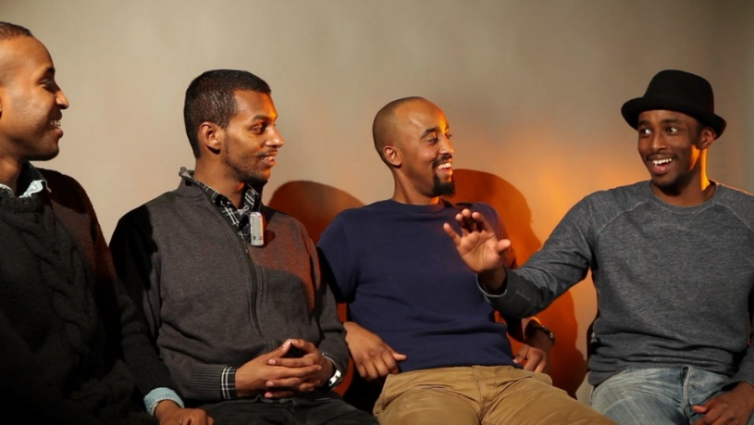
Pic 4. Camera shot from Soo Dhawoow/Tule lähemmäs/Come closer video documentary
In this discussion, all of the participants ultimately defended their right to belong to Finland by approaching the issue from different perspectives. However, they all knew there would always be people who saw them as outsiders.
For women and girls, especially if they use a veil and long dress, clothing is a kind of uniform that often excludes them from the imagined national community. They also complained that as Muslim girls they were often seen as victims of their religion and culture, being forced to act according to the norms of their family determined by patriarchal and uncivilised men (e.g. Honkasalo 2011, 12; Keaton 2006). In the project Young Muslims and resilience it seem that for young female participants it is important to discuss and express their multiple rootings and identifications in their art works, reflecting both their relationships to the Finnish society and to their local communities and families.
Religion as a space of belonging and sustenance for resilience
Both female participants of the previous project emphasised the importance of religion in their life. In the radio programme Where is my place?, one of them describes her ideas on wearing the veil, which she does not see as a Somali tradition. She states that it is her own choice not to use the veil, although she might begin to use it in the future. She continues:
I am living a kind of wild youth . . . I am a little weak at this moment, so I don’t practice my religion enough. On the other hand, I believe with all my heart . . . People think, for example in the Somali community, that I have not been taught, but I know a lot. I don’t have as good a relationship to religion as I would like, but I’m working on it . . . I could never convert to any other religion. . . . If I became involved with a Finnish man, he should convert to my religion, because a Muslim woman cannot marry a Christian man. (Where is my place?)
In her video installation, the other female participant says, ‘Islam, my own religion, is probably the strongest grounding for Somali culture, and it has perhaps moulded me most as a human being’. In the book By Other eyes, she presents a photograph from her pilgrimage, and on the page beside it is the following text (Pic 4).
The Koran and prophet Mohamed’s (peace be upon him) Sunnah are really important. They crystallise the religion and the word of God. Without them I could not think clearly. For example, if I forget one of the daily prayers, it feels like something important has been left undone. Prayers work like medicine. They help you maintain your relationship with God and be grateful for what you have; because whatever happens in life, things could always go even worse. (2015, 29)
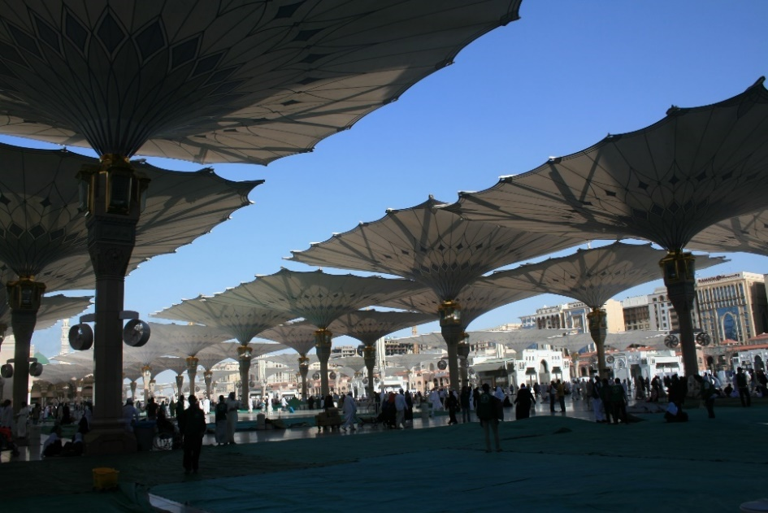
Pic 5. Photo by Najma Yusuf. from the book By Other Eyes.

She also underlined that the desire and decision to practice her religion were her own, concluding:
Some people think that young people are forced to practise religion, especially girls to wear the veil. I think that people who have these kinds of beliefs should – at least out of curiosity – read the Koran. In Islam no one should be forced. If it happens, it is wrong and against the principles of the religion. (By Other Eyes 2016, 31)
In the first works of art produced by the young male participants, religion was present in many ways, and they all admitted that it was part of their life and an important space of belonging to which they had a personal relationship. Nevertheless, in the radio programme one participant stated that religion could not be recognised from outside and was not present in his life every day. In the book My town, one participant remarked:
When I used to be more religious, I tried to avoid negative ways of thinking. Like if some strange bill came that said 800 euros, then I was like ‘whatever . . . life is life’. I had a calm kind of feeling. But when I don’t have a connection with God and bad things happen to me, I get irritated. It’s clear from your attitude whether you have a connection to something larger than you. (My Town 2012, 104)
In the documentary Soo Dhawoow/Tule lähemmäs/Come closer, religion was one of the topics that the young men wished to concentrate on. When we began to create the documentary, they had the idea of interviewing some politicians and people on the street concerning their ideas about Islam. Surprisingly, the randomly chosen people with whom they discussed in public places had more knowledge and fewer prejudices than they had expected. They decided to omit those interviews from the documentary, and instead one of the participants visited a Mosque, which had also been his Koran school, and interviewed an Imam.
In the interview, the interviewer posed some challenging questions – questions that he had often been asked himself as a Muslim man – for example, questions on the meaning of jihad, women’s rights in Saudi-Arabia, the ideas behind different customs of dressing, female circumcision and the practice of religion in the diaspora. The Imam provided long and in-depth answers, talking, for example, about the local cultural customs that influence different interpretations of religion, and opening up the definitions of jihad. To the last question, ‘How do you see the future of Muslims in Western society, and what kind of changes do you think may occur in the value system of Western Muslims?’ the Imam replied:
Muslims don’t live in a vacuum; rather, they are influenced by things and have an impact themselves. Concerning immigrants, we live in a different kind of culture from that which some are used to. But for those who were born here, this is their country, Western countries are their countries . . . those who were born here learn more – hopefully this happens – about the real meaning of religious freedom, the real meaning of democracy. . . . I think that these kinds of values of freedom – as long as they don’t disturb others’ values – are learned here. (Soo Dhawoow/Tule lähemmäs/Come closer)
The interviewer was satisfied with the answer and thanked the Imam for a good interview. Then the camera followed him to the prayer hall. In the film it was important for the young male participants to provide a wider picture of Islam and deconstruct some of the beliefs and generalisations that are often used to condemn Islam and Muslims – themselves included. It seemed that they approached questions of religion, in particular, from a political angle. The female participants seem to place a greater emphasis on their private relationship with religion, in both projects.
On the other hand – in the words of a feminist slogan – ‘personal is political’, and the young women were aware of the social dimensions of their religious commitments, as well as the strict doctrines and expectations targeted at women in Somali and other Muslim communities (e.g. Keaton, 2006; Somalis in Helsinki, 2013). In both projects all the participants underline freedom of religion and people’s right to choose their beliefs, spiritual and personal practices, as well as importance of glocal encounters and belonging, and the desire for a spirit of tolerance and understanding. As Najma Yusuf expresses it in her in the book By Other eyes by a photo (the same photo is also on the cover of the book) and narration.
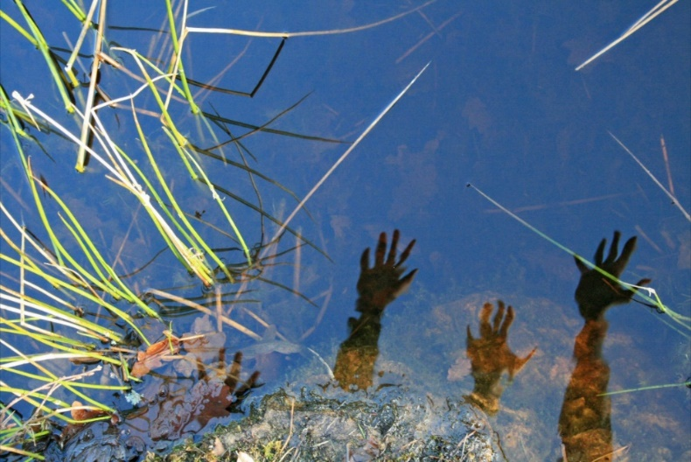
Pic 5. Photo by Najma Yusuf
This is one of my favourite pictures. In the photo there are hands from people from all the continents. It was created when I looked through the camera lens at the reflections on the water and my friends came to watch what I was doing. Together we designed a photo where we were all present.
The outcome is a work that shows how important it is for people to interact with each other. Even if people have different opinions, it shouldn’t prevent them from creating things together. Everyone has the freedom to express their own opinions and ways of thinking, but it is important to be able to communicate with people who have different ideas. Perhaps they can offer a perspective that you would never have imagined. (By Other Eyes 2015, 3)
Conclusion
In Finland it is obvious that young second generation Muslims encounter many challenges, and their belonging to Finland is contested in many ways. Even if they have grown up in Finland, they are often seen as outsiders because of their skin colour, ethnicity and/or religion. Living between different cultures and having families scattered throughout the diaspora may also raise the question of where they really belong. Anyhow, the participants of these projects project do not like to be victims of the situation, but act as ‘interpreters’ and ‘mediators’, negotiating and redefining their positionings and spaces.
In their art works, the participants explore conceptual topics such as racialisation/racism, ethnicity, class, gender, religion or nation/nationality. However, to deal with their multiple belonging, they present realms where these notions intertwine and intersect. These realms reveal a diasporic horizon that offer a space to negotiate, rupture and restructure the images, beliefs and embodied ideas offered by conceptual categorisations and the hegemonic social order (e.g. Aschcroft, 2001, 124–156; Ifekwunigwe, 1999, 190). The performative approach support our ability to produce intertextual audio-visual and literal narrations that move betwixt and between memories, embodied and lived experiences and the desired future, creating interrupting perspectives and potential transformation (Conquergood, 2009; O’Neill, 2008; Oikarinen-Jabai, 2015a).
Whether, in their art works, the participants gaze back to their nostalgic homeland or carve new spaces in Finland or other places, their ‘homing desire’ and diasporic imagination assist them in claiming a cultural citizenship that cross borders (Aschcroft 2001; Hua 20l1; Oikarinen-Jabai 2015). When doing this, they are also able to negotiate their own contested national identifications and sense of belonging and create fresh narrations of Finns and Finnishness. Instead of advocating normalization, the participants empower marginalised identities, in the process creating kinds of diasporic ‘minoritarian identities’ that supported their resilience (Butler 2000; Sheikh 2001).
In their audio, visual and literal narrations, these imaginary and real homes meet and find fresh expression. Furthermore, in creating their productions they are able to challenge racism, islamophobia and the prejudices they constantly encounter, create hybrid counter discussions, and deconstruct and reform images and representations hidden in language and visual representations (e.g. Friedman 2005; Gough-Dijulio & Wolcott, 1997). Through creating works of art with the young participants, we other participants get to know these young people well and we have easier to present experiences, emotions and knowledge that are difficult to express verbally, especially with the academic vernacular (e.g. Manzo & Brightbill 2007; O’Neill & Hubbard 2010). A challenge to us is to remain willing to move and shift between different epistemological understandings, to listen carefully without categorising, and to observe our work as ‘translators’ and ‘mediators’ from a critical perspective (Jungnickel & Hjort 2014; Koobak 2014). In a performative participatory research setting it is important to trust in not-knowing, being sensitive to the participants’ perspectives, and allow the unfinished process to take the research forward.
References

Ahmed, S. (2000). Strange encounters: Embodied others in postcoloniality. London: Routledge.

Anzaldúa, G. & Moraga C. (1983). This Bridge Called My Back: Writings by Radical Women of Colour. New York: Kitchen Table.
Anzaldua, G. (1987). Borderlands/La Frontera. San Francisco: Aunt Lute Books.
Ashcroft, B. (2001). Post-colonial transformation. London: Routledge.
Behar, R. (1993). Translated Woman. Crossing the Border with Esperanza’s Story. Boston: Beacon Press.
Behar, R. (1995). Introduction: Out of Exile. In R. Behar & D. Gordon (Ed.), Women Writing Culture. Berkeley: University of California Press (pp.1–32).
Brah, A. (2001). Difference, diversity, differentiation. In K. Bhavnani (Ed.), Feminism and “Race”. Oxford: Oxford University Press (pp. 456–478)
Brah, A. (1996). Cartographies of diaspora, contesting identities. London: Routledge.
Butler, J. (2000). Competing universalities. In J. Butler, E. Laclau, & S. Zizek (Eds.), Contingency, hegemony, universality. Contemporary dialogues of the Left. London: Verso (pp. 136–181).
Cixous, H. (1993). Three steps on the Ladder of Writing. (Trans. S. Cornell & S, Sellers). New York: Columbia University Press.

Conquergood, D. (2009). Performance studies: Interventions and radical research. In H. Bial (Ed.) Performance studies reader. New York: Routledge (pp. 311–322).

Denzin, N. (2003). Reading and Writing Performance. Qualitative Research, vol. 3(2), 243–268.

Finley, S. (2005) Arts-Based Inquiry: Performing Revolutionary Pedagogy. In N. Denzin & Yvonne Lincoln (Eds.), The Sage Handbook of Qualitative Inquiry. London: Sage Publications (pp.959–967).

Friedman S. (2002). “Border Talk,” hybridity, and performativity cultural theory and identity in the spaces between difference. Retrieved from
http://www.eurozine.com/articles/2002-06-07-friedman-en.html
Fusco, C. (1998). The Other History of Intercultural Performance. In N. Mirzoeff (Ed.), The Visual Culture Reader. London: Routledge (pp. 363–371).

Gough-Dijulio & Wolcott A. (1997). Just Looking or Talking Back. A Postmodern Approach to Art Education. In J. Hutchens & M. Suggs (Eds.), Art Education: Content and Practice in Postmodern Era. Virginia: The National Art Education Association (pp. 143–152).

Haraway, D. (2004). The Haraway Reader. New York: Routledge.
Haseman, B. (2006). A manifesto for performative research. Media International Australia incorporating Culture and Policy, "Practice-led Research", 118, 98–106.

Honkasalo, V. (2011). With Girls; Multiculturalism and Gender Equality in Youth Work. (Tyttöjen kesken: Monikulttuurisuus ja sukupuolten tasa-arvo nuorisotyössä). Dissertation. University of Helsinki.

hooks, b. (1995). Art on my mind: Visual politics. New York: The New Press.

Hua, A. (2011). Homing desire, cultural citizenship, and diasporic imaginings. Journal of International Women's Studies, 12(4), 45–56.

Ifekwunigwe, J. (1999). Scattered Belongings. Cultural Paradoxes of ”Race”, Nation and Gender. London: Routledge.

Jagne, S. (1994). African Women and The Category “Woman”: Through the Works of Mariama Bâ and Bessie Head. Dissertation. State University of NewYork.

Joseph M. (1999). Nomadic Identities: The Performance of Citizenship. Minneapolis, MN: University of Minnesota Press.

Jungnickel K. & Hjort L. (2014). Methodological entanglements in the field: Methods, transitions and transmissions. Visual Studies, 29(2), 136–145.

Kadar, M. (1992). Coming to Terms: Life Writing – From Genre to Critical Practice. In M. Kadar (Ed.), Essays on Life Writing: From Genre to Critical Practice. Toronto: University of Toronto Press (pp. 3–15).

Keaton T. D. (2006). Muslim Girls and the Other France, Race, Identity Politics & Social Exclusion. Bloomington: Indiana University Press.

Koobak, R. (2014). Six impossible things before breakfast: How I came across my research topic and what happened next. In N. Lykke (Ed.), Writing academic texts differently: Intersectional feminist methodologies and the playful art of writing. New York: Routledge (pp. 95–110).

Kristeva J. (1992). Muukalaisia Itsellemme (Strangers to Ourselves 1988) (trans. P. Malinen). Helsinki: Gaudeamus.

Lather, P. & Smithies, C. (1997). Troubling the Angels: Women Living with hiv/aids. Oxford: Westview Press.
Liebenberg, L. 2009: The Use of Image-Based Methods in Research with Youth. In L. Liebenberg & M. Ungar (eds) Researching Resilience. Toronto: Toronto University Press, 128–147.
Manzo, L. & Brightbill N. (2007). Toward a participatory ethics. In S. Kindon, R. Pain, & M. Kesby (Eds.), Participatory action research approaches and methods: Connecting people, participation and place. London: Routledge (pp. 33–40).
Minh-ha, T. (2011). Elsewhere, within here: Immigration, refugeeism and the boundary event. New York: Routledge.
Minh-ha, T. (1991). When the Moon Waxes Red: Representation, Gender and Cultural Politics. New York: Routledge.
Oikarinen-Jabai, H. (2015a). “I Guess We Are Some Kind of a New Generation of Finns and Each One Also Slightly Something Else.” Second-generation Finnish Somalis as Creators of Images of Diverse Finnishness. In M. Kallio & J. Pullinen (Eds.), Conversations on Finnish Art Education. Helsinki: Aalto Arts (pp. 34–47).
Oikarinen-Jabai H. (2015b). Making Space: Finnish Somali Youth Discussing and Making Audio Visual Narratives (Tilaa tekemässä: suomalaiset somalinuoret pohtimassa ja tuottamassa audiovisuaalisia esityksiä). In A. Arlander, H. Erkkilä, T. Riikonen & H. Saarikoski (Ed.), Performance Studies (Esitystutkimus). Helsinki: Kulttuuriosuuskunta Patruuna (pp. 113–138).
O’Neill, M. (2011). Participatory methods and critical models: Arts, migration and diaspora. Crossings: Journal of Migration and Culture, 2, 13–37.
O’Neill, M. (2009). Making connections: Ethno-mimesis, migration and diaspora. Psychoanalysis, Culture and Society, 14, 289–302.
O’Neill, M. (2008). Transnational refugees: The transformative role of art? Retrieved from http://www.qualitative-research.net/index.php/fqs/article/view/403/873Social
O’Neill M. & Hubbard P. (2010). Walking, sensing, belonging: ethno-mimesis as performative praxis. Visual Studies, 25(1), 46–58.
Pink, S. (2007). Doing Visual Ethnography. Los Angeles: Sage.
Richardson, L. (2005). Writing. A Method of Inquiry. In N. Denzin & Y. Lincoln (Eds.) The Sage Handbook of Qualitative Inquiry. London: Sage Publications (pp. 957–967).
Richardson L. (1997). Fields of play: constructing an academic life. New Brunswick: Rutgers University Press
Sheikh, S. (2002). Under deconstruction, mainstreaming and marginalization in the changing welfare states of the Nordic countries. In M. Muukkonen (Ed.), Under de(construction): perspectives on cultural diversity in visual and performing arts Helsinki: NIFCA (pp. 85–92).
Somalis in Helsinki (2013) Somalis in European cities. Retrieved from
http://www.opensocietyfoundations.org/ reports/somalis-helsinki

St. Pierre, E. (2005) Writing as a Method of Nomadic Inquiry, In N. Denzin & Y. Lincoln (Eds.) The Sage Handbook of Qualitative Inquiry. London: Sage Publications (pp. 967–973).
Tolia-Kelly, D.P. (2007). Participatory art: Capturing spatial vocabularies in a collaborative visual methodology with Melanie Carvalho and South-Asian women in London, UK. In S. Kindon, R. Pain, & M. Kesby (Eds.), Participatory action research approaches and methods: connecting people, participation and place. London: Routledge (pp. 132–140).
Viswesvaran, K. (1994). Fictions of Feminist Ethnography. University of Minnesota Press: Minneapolis.
Yuval-Davis, N. (1997). Gender & Nation. London: Sage.

Yuval-Davis, N. (2011). Power, intersectionality and the politics of belonging. FREIA Working Paper Series No. 75. Retrieved from
http://vbn.aau.dk/files/58024503/FREIA_wp_75.pdf

Web pages http://174494.resilienceresearch.org/

Productions discussed
Soo Dhawoow/Tule lähemmäs/Come closer video documentary (2015) by Akram Farah, Hassan Omar, Jabril aka Dice, Mohamed Isse & Ahmed Muhamed. Production H. Oikarinen-Jabai & J. Gräfnings.
Toisin silmin/By Other eyes (2015) Najma Yusuf. Oikarinen-Jabai H. (ed). Turku: Siirtolaisuusinstituutti.
By my eyes/Minun silmin video installation by Najma Yusuf (2013). Production H. Oikarinen-Jabai. Sound production T. Salomaa.
Minun Helsinkini/My Helsinki/Waa/ Magaaladeydii Helsinki video documentary (2013) by Akram Farah, Hassan Omar, Jabril aka Dice, Mohamed Isse & Ahmed Muhamed. Producers H. Oikarinen-Jabai & S. Sallinen. First presented in 2010.
Mun stadi/My town (2012) Ahmed Kahie, Akram Farah, Hassan Omar, Jabril aka Dice, Mahad Ali, Mohamed Isse & Ahmed Muhamed. H. Oikarinen-Jabai (Ed.) Turku: Institute of Migration.

Where is my space/Mis on mun tila? Radio programme (2011) by Hassan Omar, Akram Farah, Mohamud Isse, Ahmed Muhamed, Jabril aka Dice, Shaka de Bresche & Asiya Ubah Abdillah. 6 October 2011, H. Oikarinen-Jabai, L. Tajakka, K. Ranta & H. Karisto (eds). YLE (Finland’s national public service broadcasting company).
Experiencing Helsinki. A video made by Life Breather mobile application by youth with immigrant background. Production Lily Diaz, Jürgen Sheible ja Helena Oikarinen. First presented in Helsinki 31.4.2010.

This project, funded by Kone Foundation, is conducted at the University of Helsinki, Department of Social Studies.
For example I organised this workshop with Professor Lily Diaz, researcher Jürgen Scheible and a group of graduate students from the Media Department of Aalto University School of Arts & Design the ‘Life Breather mobile application workshop’, where participants created narratives of their relationships with the cultural heritage of Helsinki.
For example, in 2012 the exhibition Young Helsinki at the Finnish Museum of Photography showed a lot of material produced by participants with multiple national, ethnic and linguistic backgrounds.

