TEMPLATE
Full Research Paper – Maximum 10 pages

This document provides a template for a Full Research Paper submission for EFYE 2020 conference. Submissions must use the correct formatting. Word Styles (on the home panel) are shown in block quotes with examples below.

Full paper submissions feature significant theoretical reviews, research studies in areas of emergent or innovative educational practice, case studies, evaluations, or projects. Full Research Paper submissions are a minimum of six pages and maximum of 10 pages, including references.

The authors must have the copyright to all the material used in the submission or received written permission to use the protected material.

Before you submit the final version of your Full Paper, please ensure you adhere to the following criteria:

- The submission file must be uploaded in PDF file format
- The entire document is formatted based on this template
All URL addresses included must be activated
- All authors’ names must be removed from the submission, with author and year used in the bibliography and footnotes instead of the authors’ names
- Submission size is limited to 20MB; please ensure you are using images in a compressed format to keep file size low.
- It is expected that authors will submit carefully written and proofread material. Careful checking for spelling and grammatical errors must be performed.
- Use either British, or US, spelling but not a mix of the two
- Please do not add any page numbers as they will be added.

For any questions regarding submission or this template, please contact our EFYE 2020 Event Organizers efye2020@au.dk

Insert your title here [Paper title style]

The Abstract should be no more than 200 words and 1 paragraph only. Avoid quotation and citing references in your abstract. … [Abstract and keywords style]

Keywords: One line of key or focus terms by which your paper can be indexed.

First level heading [First level heading style]

Body of your paper … use Times New Roman 11 point, left aligned, single-spaced. Blank lines before and after headings and paragraphs are to be sized the same as text lines, i.e., 11 point (Times NR).

For paragraphing, use a single blank line between each paragraph, and no indents. Do not use Spacing Before or Spacing After your paragraphs. [Paper body style]

Second level heading [Second level heading style]

Put a blank line before and after the second level heading. [Paper body style]

Third level heading [Third level heading style]
Do not include a blank line after a third level heading. Use bulleted or numbered lists in preference to third level headings where possible. [Paper body style]

[This is a quotation] Use Times New Roman 11 point, left aligned, single-spaced, indented 1.0 cm left and right, not italicized, without quote marks, one blank line before and after. Indents may be varied slightly from 1.0 cm to improve the fit. Referencing for the quotation may be given in the running text immediately before the quotation, or may be appended to the end of the quotation. In general, very short quotations using only a few words should be given with quote marks in your running text, whilst only longer quotations using a line or more should be formatted as quotations. (Reference) [Quotation style]

This is a bulleted list:

- Times New Roman 11 point
- Left aligned, single spaced
- No indents except a hanging indent 0.5 cm.[Bulleted List style]

This is an ordered list:

- Times New Roman 11 point
- Left aligned, single spaced
- No indents except a hanging indent 0.5 cm. Indentation may be varied slightly to improve the fit.
- Select only from these kinds of ordering: 1. 2. 3 alternatively, i. ii. iii, or a. b. c 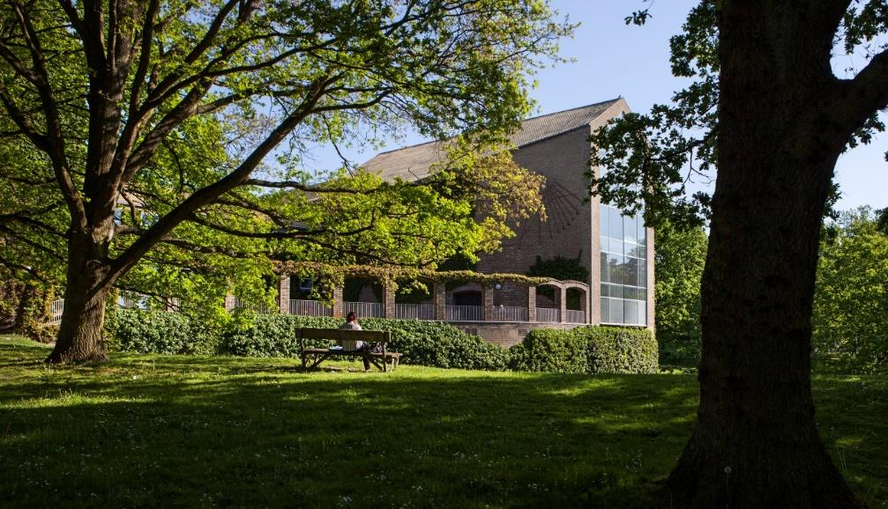

Figure 1: Sample of a figure (legend is below figure) [Figure style]

Figures must be placed in their correct location in your running text. All figures should be included in your Word file, and not in separate graphic or drawing package format. Labeling should be consistent with the fonts used in the text of your paper, i.e., Times New Roman. Number sequentially, Figure 1, Figure 2, etc. Do not use variations such as Figure 1a, 1b.

Tables and figures
Each table should have a descriptive title (using the current style) and each column an appropriate heading. In general, use Times New Roman 11 point and other body text specifications for all text within a table and its title, though reduced point may be used as required for narrow columns. Tables should have a title with consecutive numbering

Table 1 Table layout. [Table title placed above]
Table Rows [ Table content] | Cell one | Cell two
Second Row | 1 | 2
Third Row | 2 | 3
Fourth Row | 4 | 5

Use APA 6th edition style for references. This style prescribes alphabetical order by first author. Use Times New Roman 11 point, left aligned, hanging indent 0.5 cm, with no blank lines. Wherever possible, insert URLs for references. However, do not insert URLs for publications that only offer pay per view, institutional subscriber, or on campus only access to full text. The date of viewing may be omitted for journal and proceedings URLs considered to be of high reliability. All the references should be arranged in alphabetical order. If a work has three (3), four (4) or five (5) authors, cite all authors the first time and from then on include only the last name of the first author followed by the words et al.
The following list provides examples of referencing for the main kinds of publications:
References [First level heading style]

[For an article in a journal] Coates, H. (2005). The value of student engagement for higher education quality assurance, Quality in Higher Education, 11(1), 25-36, https://www.tandfonline.com/doi/full/10.1080/13538320500074915
[Book] Johnston, B. (2010). The first year at university: Teaching students in transition. UK: Maidenhead: SRHE and Open University Press
[Chapter in a book] Gurtner, J-L., Monad, I., & Genoa, P. (2001). Towards a multilayer model of context and its impact on motivation in: Volet and Järvelä (eds.) Motivation in Learning Contexts. Theoretical Advances and methodological Implications. Oxford, UK. Elsevier Science Ltd. pp 189-201.
[Report, proceedings, and unpublished literature (a)] Ananiadou, K., and Claro, M. (2009). 21st Century Skills and Competences for New Millennium Learners in OECD Countries. Working Paper. Retrieved at http://repositorio.minedu.gob.pe/handle/123456789/2529?show=full
[Report, proceedings, and unpublished literature (b)] Kahu, E., & Gerrard, H. (2018). Engaging online students in citizenship through weekly critical reflections. Proceedings of 2018 FLANZ Conference. 9-11 April 2018, Victoria University, Kelburn Campus, Wellington, New Zealand.
[Report, proceedings, and unpublished literature (c)] Yang, H., Bell, M. G. H., and Meng, Q., (1997). Equilibrium zone reserve capacity under network capacity constraints. Working paper, The Hong Kong University of Science and Technology.
[Newspaper or magazine] Noemi Katznelson. Unge, der får afslag på studieplads, kan opleve et fuldstændigt identitetstab. Politiken, 26 Juli 2019
[Internet source (with title, date of access and the universal resource locator in full)] Aarhus Universitet. (2018). Aarhus University invests in digital development of teaching activities. Retrieved from http://newsroom.au.dk/en/news/show/artikel/aarhus-universitet-investerer-i-teknologisk-udvikling-af-undervisningen/.
[Government legislation (a)] EDUCATION, ENGLAND, Higher Education and Research Act 2017 (Commencement No. 1) Regulations 2017.

Acknowledgements Any acknowledgements, the authors wish to make should be included in a separate headed section at the end of the manuscript but before the list of references.

