Title of the abstract
Presenting Author and Non-Presenting Author
Affiliation of the author(s)
Abstract: In case the abstract has more than one author, please add the co-authors. If the authors have different affiliations, put one block (i.e., author names and affiliation) for each affiliation. The presenting author should be marked in bold.
The abstract should fit in a single page in the format of the template. The abstract may contain text as well as figures. Please, do not insert any tables. References should follow the IEEE citation style [1].
The authors are responsible for making sure that they have the full permission to use any graphical material such as figures or photographs included in the abstract.
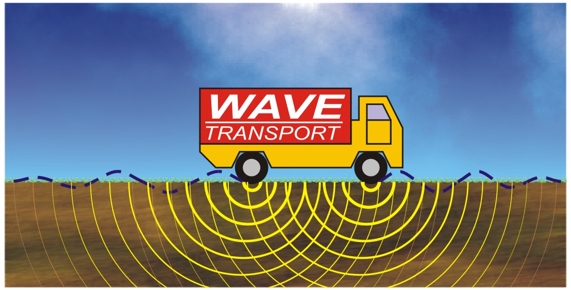
Figure 1: Just an example.

References
[1] IEEEDataPort. Help and Support. “How to Cite References: IEEE Documentation Style”. [Online]. Available: https://ieee-dataport.org/help/how-cite-references-ieee-documentation-style. [Accessed June 30, 2022].

