Title of the Abstract
First Author¹*, Second Author², Third Author¹
¹Affiliation, City, Country
²Affiliation, City, Country
*Corresponding author: email@address.com
Word count: maximum 300 words (excluding title, affiliations, figure caption, and references).
Beneath the quiet surface of the sea lived the youngest daughter of the Sea King, a mermaid whose voice was said to be clearer than the bell of the deepest cathedral. While her sisters were content with coral gardens and drifting currents, she longed to understand the world above the waves [1].
On the day she was permitted to rise to the surface, the little mermaid witnessed a great ship illuminated by lantern light and laughter. A sudden storm shattered the calm, and as the vessel broke apart, she rescued a young prince from the dark water.
Seeking a path to the human world, she turned to the Sea Witch, whose knowledge came at a terrible price. In exchange for her voice, the little mermaid was granted legs, though each step on land would feel like walking upon sharp blades [2].
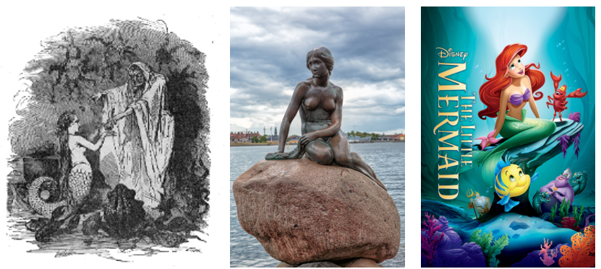
This tale illustrates themes of longing, sacrifice, and transformation, highlighting how identity and purpose can evolve through choice [3].

Figure 1. Caption describing the figure. Depictions of the little mermaid through time, from typical-of-time artwork, to the (rather disappointing) statue in Copenhagen and finally the modern Disney adaptation.

References:
1. Andersen, H.C. “Fairy Tales and Stories.” C.A. Reitzel, Copenhagen (1837).
2. Zipes, J. Hans Christian Andersen: “The Misunderstood Storyteller.” Routledge (2005).
3. Yamato, Lori. "Surgical Humanization in H. C. Andersen’s “The Little Mermaid”." Marvels & Tales, vol. 31 no. 2, 2017, p. 295-312., https://dx.doi.org/10.13110/marvelstales.31.2.0295

