Title of the paper

John J. Brownt a,*, Robert Z. Nixon b

a Institution of John J. Brownt
b Institution of Robert Z. Nixon

*Email presenting author:

This abstract template is provided to maintain a consistent style across the conference booklet. We appreciate your adherence to the formatting guidelines. You may download and use this template as many times as you require.
Formatting guidelines: Institution names should be in Arial, 10pt, left-aligned, and italicized. Main text should be in Arial, 12pt, justified. References must be in Arial, 10pt, left-aligned, and cited using superscript numbers (e.g., ¹) in the order they appear in the text. Please format references according to the style shown below. The entire abstract, including figures and references, must not exceed one page. Figures must include captions in Arial, 10pt.

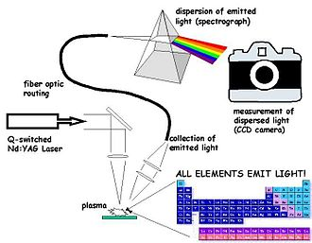

Figure 1 Laser-Induced Breakdown Spectroscopy

References
¹ Cremers, D. A.; Radziemski, L. J. Handbook of Laser-Induced Breakdown Spectroscopy; John Wiley & Sons: Chichester, West Sussex, England; Hoboken, NJ, 2006.

