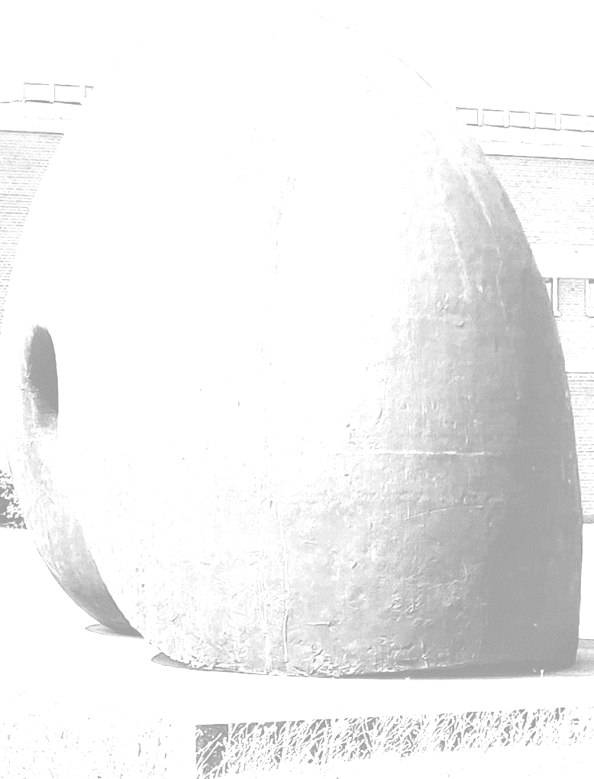
7th Aarhus Immunotherapy Symposium (AIS7)

Thursday November 25th 2021

Confirmed speakers:

Stefan Vieths, Paul-Ehrlich-Institut, Langen, DE
José Carballido, Novartis, Basel, CH
Karen Jeppesen, Aarhus University, Aarhus, DK
Duncan Howie, Enara Bio, Oxford, UK
Peter Holst, InProTher, Copenhagen, DK
Antoon van Oosterhout , Imcyse, Liege, BE
Marina Romero-Ramos, Aarhus University, DK

